

|  |  |
| --- | --- |
| **ASSIGNMENT** | |
| **Course Code** | OMC451B |
| **Course Name** | Personal Finance |
| **Programme** | B. Tech. |
| **Department** | Computer Science & Engineering |
| **Faculty** | Faculty of Engineering & Technology |

#### 

|  |  |
| --- | --- |
| **Name of the Student** | Kaushal Vashisth |
| **Reg. No** | 18ETCS002147 |
| **Semester/Year** | 7th semester / 2018 batch |
| **Course Leader/s** | N. Suresh |

|  |  |  |  |  |  |  |  |  |
| --- | --- | --- | --- | --- | --- | --- | --- | --- |
| **Declaration Sheet** | | | | | | | | |
| Student Name | Kaushal Vashisth | | | | | | | |
| Reg. No | 18ETCS002147 | | | | | | | |
| Programme | B. Tech. | | | | | Semester/Year | 7th sem /2018 batch | |
| Course Code | OMC451B | | | | | | | |
| Course Title | Personal Finance | | | | | | | |
| Course Date |  | | to | |  | | | |
| Course Leader | N. Suresh | | | | | | | |
| **Declaration**  The assignment submitted herewith is a result of my own investigations and that I have conformed to the guidelines against plagiarism as laid out in the Student Handbook. All sections of the text and results, which have been obtained from other sources, are fully referenced. I understand that cheating and plagiarism constitute a breach of university regulations and will be dealt with accordingly. | | | | | | | | |
| Signature of the Student | |  | | | | | Date |  |
| Submission date stamp  (by Examination & Assessment Section) | |  | | | | | | |
| Signature of the Course Leader and date | | | | Signature of the Reviewer and date | | | | |
|  | | | |  | | | | |

# **Contents**

____________________________________________________________________________

**Declaration Sheet** ii

**Contents** iii

**Question No. 1** 5

A.1 Plan for Unexpected Expenditure, Fixed Expenses and Variable Expenses 5

A.2 Plan for Savings and Investments for retirement 5

A.3 Plan for Health and Property Insurance 5

A.4 Conclusion of the study with stance and justification 5

**Question No. 2** 6

B.1 Short term/Medium for 1-6 Years 6

B.2 Long term for 10-15 years 6

B.3 Conclusion of the study with stance and justification 6

**Question No. 3** 7

C.1 Select two stocks of your choice listed in National stock exchange from different sector and collect previous five-year monthly data of share prices of selected stock and corresponding index data. 7

C.2 Determine Systematic and Unsystematic risks of each stock 7

C.3 Determine the Expected return of the stocks using CAPM Model assuming risk free return as 6%. 7

C.4 Conclusion of the study with stance and justification 7

|  |  |  |  |
| --- | --- | --- | --- |
|  | **Assessment (CE + SEE)** | | |
| Reg.No. | 18ETCS002147 | Name of the Student | **Kaushal Vashisth** |

|  |  |  |  |  |  |  |
| --- | --- | --- | --- | --- | --- | --- |
| **Component - 1:** |  |  |  | | | |
| Sections |  | Marking Scheme | **Marks** | | | |
| Max Marks | |  |  |
| **Part-A**  **(CO1, CO3, CO5)** |  | Prepare Personal Budget for the period of five years from 2022-2027 with the details assuming an income increment of 5-10% for each year which should include |  |  |  |
| A.1 | Plan for Unexpected Expenditure, Fixed Expenses and Variable Expenses | 5 |  |
| A.2 | Plan for Savings and Investments for retirement | 5 |  |
| A.3 | Plan for Health and Property Insurance | 5 |  |
| A.4 | Conclusion of the study with stance and justification | 3 |  |
|  | Part-A, Max Marks |  | 18 |
| **Part-B (CO2)** |  | Prepare monthly Amortisation schedule for loan assuming rate of interest for |  |  |  |  |
| B.1 | Short term/Medium for 1-6 Years | 5 |  |
| B.2 | Long term for 10-15 years | 5 |  |
| B.3 | Conclusion of the study with stance and justification | 2 |  |
|  | Part-B, Max Marks |  | 12 |
| **Part-C**  **(CO4)** | C.1 | Select two stocks of your choice listed in National stock exchange from different sector and collect previous fiveyear monthly data of share prices of selected stock and corresponding index data. | 6 |  |
| C.2 | Determine Systematic and Unsystematic risks of each stock | 8 |  |
| C.3 | Determine the Expected return of the stocks using CAPM Model assuming risk free return as 6%. | 4 |  |
| C.4 | Conclusion of the study with stance and justification | 2 |  |
|  | Part-C, Max Marks |  | 20 |
|  | **Total Component 1 (CE)** |  | **50** |
|  |  |  |  | |  |  |

|  |  |  |  |
| --- | --- | --- | --- |
| **Component - 2: Examination** |  |  |  |
| **Examination** | **Max Marks** | **First Examiner Marks** | **Second Examiner Marks** |
| SEE | **50** |  |  |
| SEE marks reduced to 50 Marks |  |  |  |

|  |  |  |  |  |  |  |
| --- | --- | --- | --- | --- | --- | --- |
| Component-1 (CE)Total 50 |  |  | Pass |  | Fail |  |
| Component-2: SE Examination - 50 |  |  | Pass |  | Fail |  |
| Course Marks (Max 100 ) |  | | Pass |  | Fail |  |
| IMPORTANT: 1. Component 1 and 2 total marks have to be rounded off to the next higher integer and entered in the above fields.  2. A minimum of 40% required for a pass in both components. | | | | | | |
| Signature of Course Leader Signature of Student | | | | | | |

# **Question No. 1**

Prepare Personal Budget for the period of five years from 2022-2027 with the details assuming an income increment of 5-10% for each year.

**Solution to Question No. 1:**

To create personal budget we need to follow the following steps:

1. Set your financial goals: example: Pay off car loan.
2. Estimate your income.
3. Budget for unexpected expenses.
4. Budget for fixed expenses.
5. Budget for variable expenses.
6. Record what you spend.
7. Review your spending and saving pattern.

For this personal budget we are using income increment of 7%.

Income estimation:

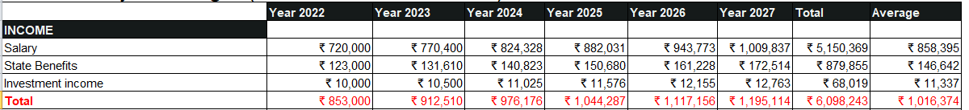

Income chart:

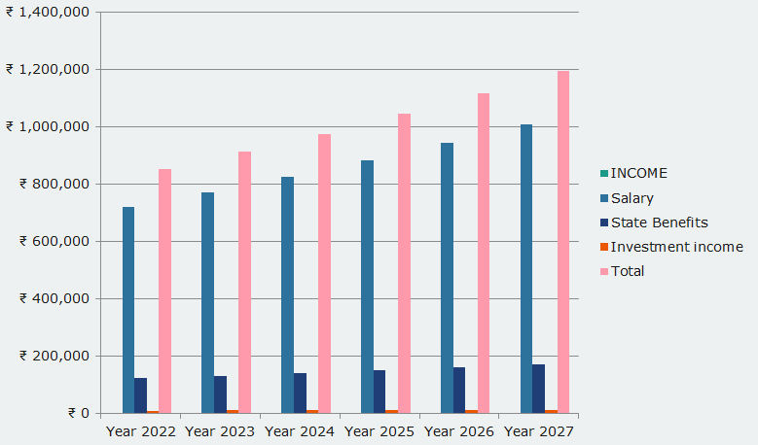

## A.1 Plan for Unexpected Expenditure, Fixed Expenses and Variable Expenses

Plan for Fixed expenses:

These are the expenses you have that don’t change month-to-month. Your mortgage or rent, car payment, and insurance are examples of fixed expenses. They may vary slightly from year-to-year (say, a rent increase) but overall you can count on them to stay the same for at least a year at a time. That’s why we have shown

Yearly Budget to handle fixed expenses:

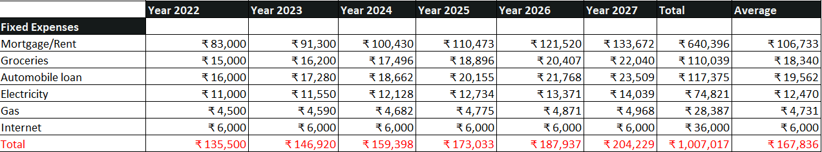

Yearly fixed expenses bar graph:

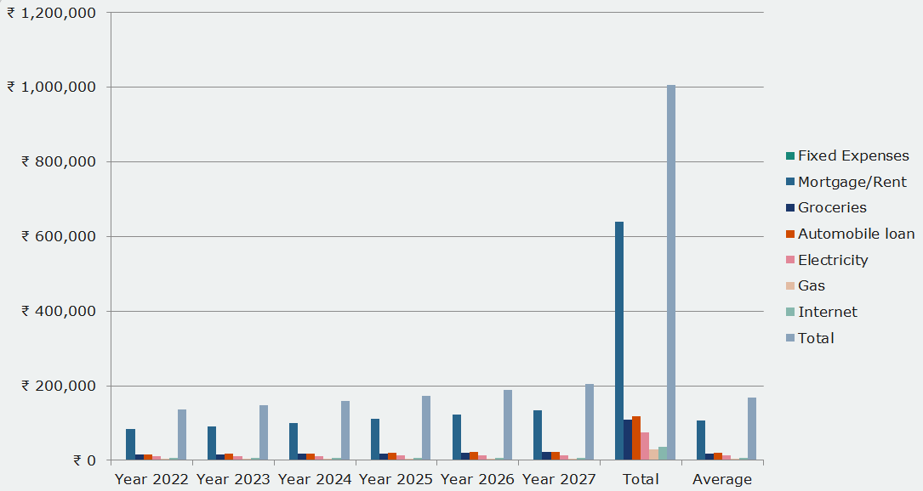

Plan for Variable expenses:

Just as the name says, these are your expenses that will vary month-to-month and are probably the largest spending category. Variable expenses include such things as groceries, Food, utilities, entertainment expenses, and clothing. By keeping track of these expenses over time, you can get a better idea of how much you’re spending each month and plan accordingly. Utilities can become a fixed expense if your service provider offers an “equalizer” plan. These plans average your usage over time and charge the same each month, rather than spiking during times of increased usage (think summer AC bills in hot climates).

Yearly Budget to handle Variable expenses:

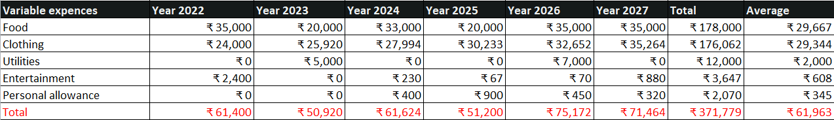

Yearly Variable expenses bar graph:

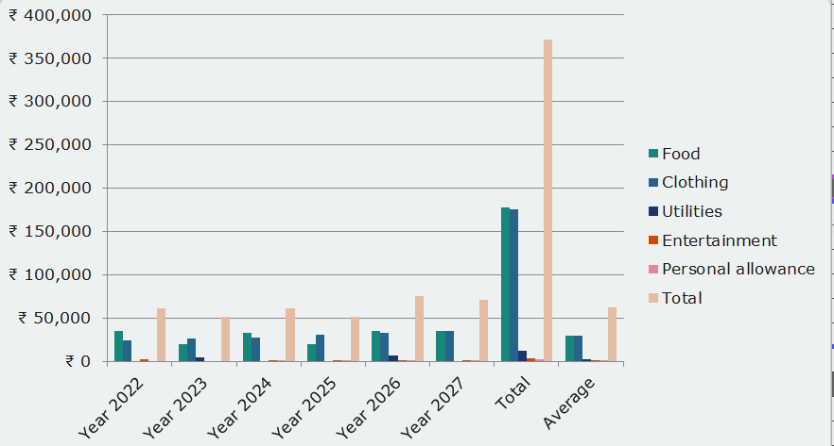

Unexpected expenses:

Your emergency fund should be used for expenses that fall outside the categories of annual bills, irregular maintenance, or predictable health costs. Truly unexpected expenses could be:

* Living expenses for several months after you lose your job
* Unusual medical bills that health insurance doesn't cover
* Plane tickets to attend an unexpected funeral

These expenses are not only irregular and unforeseen; they are related to unexpected or once-in-a-lifetime events, rather than more common activities.

Plan for Unexpected expenses:

When you plan your budget to include annual bills and irregular maintenance, you are able to save the money in your emergency fund for truly unexpected expenses.

At a minimum, you should have an emergency fund that can cover three to six months of:

* Rent or mortgage payments
* Utilities
* Emergency savings
* College savings
* Prescriptions

However, just because you have this amount set aside doesn't mean you should stop saving. If your monthly budget is set up to continue adding a small amount per month into your emergency savings, you will be able to plan and pay for unexpected expenses that come your way without falling into debt or missing important bills.

Yearly Budget to handle unexpected expenses:



Yearly unexpected expenses bar graph:

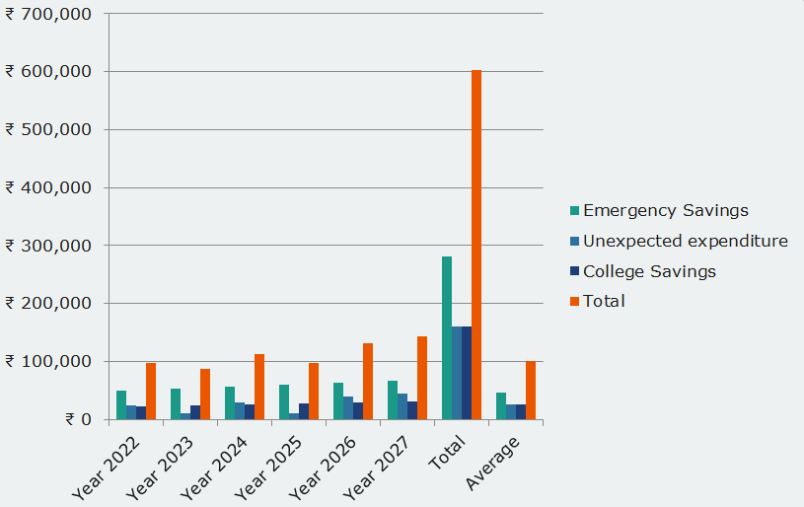

## A.2 Plan for Savings and Investments for retirement

Several retirement plans help in accumulating a considerable sum for your retired life. Some of them are listed below:

National Pension System

National Pension System (NPS) is a government scheme which intends to provide social security to the working class. Employees working in the public, government, and private sectors can invest in this scheme. Moreover, even those employed in the unorganised sector can also invest in NPS. Under this scheme, the employees will invest in a pension account at regular intervals.

Public Provident Fund

Public Provident Fund (PPF) is a government savings scheme covered under Section 80C of the Income Tax Act, 1961. You can save up to Rs 46,800 a year in taxes by investing in PPF. You can invest up to Rs 1,50,000 a year, and these accounts come with a lock-in period of 15 years. Investing in PPF is an excellent way of planning your retirement as it offers an attractive rate of return.

Mutual Funds

Mutual funds are one of the best private schemes to plan your retirement. These are capable of offering returns in the range of 12% to 15% a year. Also, when you invest with a long-term horizon, you will unleash the power of compounding. Since retirement planning is done with a long-term horizon, you can initially invest aggressively in equity funds and then switch your investments to debt funds as you near your retirement. Doing this will ensure that you have accumulated a considerable sum on which you can fall back in your retired life.

Yearly Budget for reteirement savings:

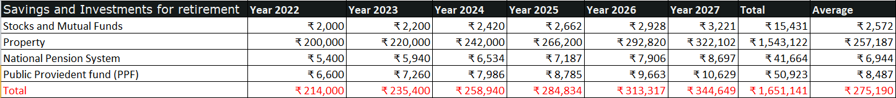

Yearly budget for retirement bar graph:

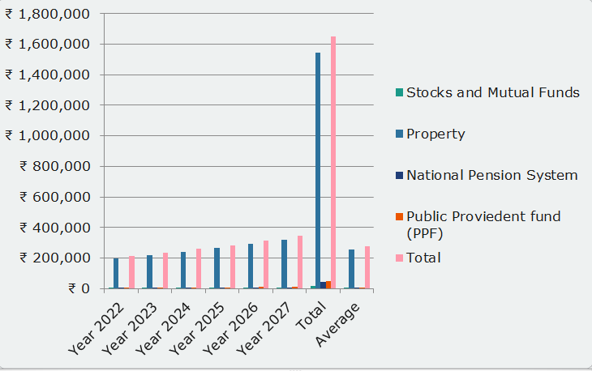

## A.3 Plan for Health Insurance

Health insurance provides financial protection in case you have a serious accident or illness. For example, a broken leg can cost up to $7,500. Health coverage can help protect you from high, unexpected costs.

With Marketplace coverage, you’ll get access to preventive services — like shots and screening tests — at no cost to you. Getting recommended preventive services is a key step to good health and well-being.

When you apply for insurance using the Health Insurance Marketplace, you’ll find out if you qualify for savings that can make insurance less expensive. Before you apply, select your household size, state, and income range to see if you may qualify for financial help.

Budget for Health insurance:



## Yearly Bar chart for Health insurance:

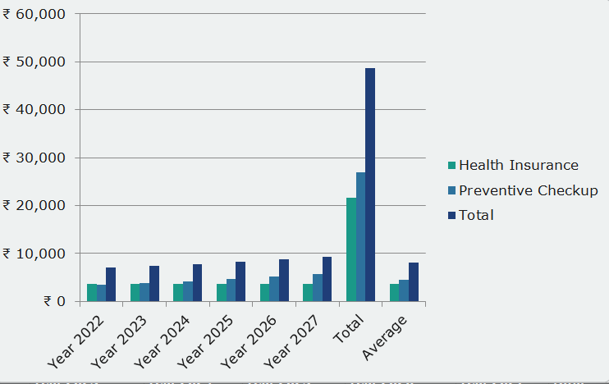

## A.4 Conclusion of the study with stance and justification

Importance of building budget:

A budget is a plan for using money to meet wants and needs. Having a budget is necessary for successful financial planning. By using a budget, you will learn how to live within your income and how to spend your money wisely. You will also develop good money management skills that will help you reach your financial goals.

Full Budget is shown below with 7% increment in income:

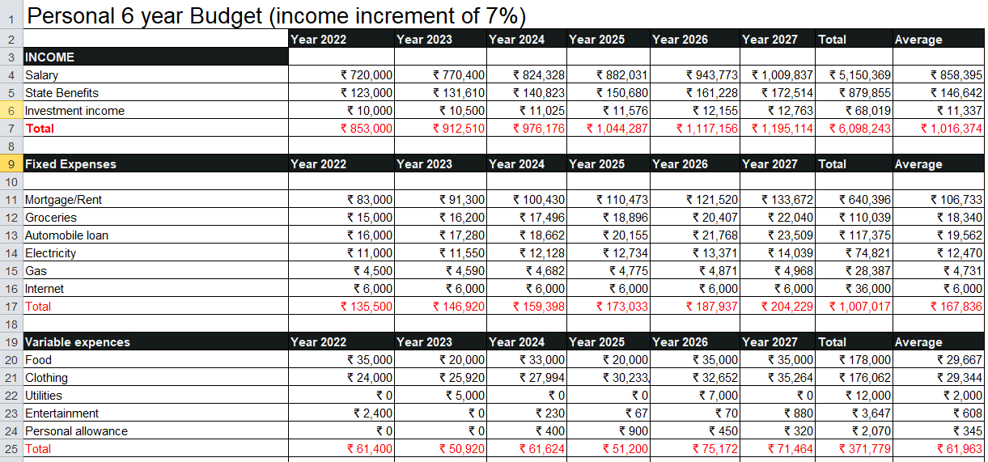

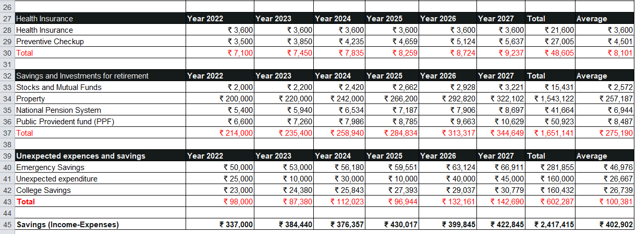

From the above budget we can conclude that on an average 4.02 lakh rupees can be saved yearly.

Within 6 year a person can save an amount of 24.17 lakh rupees with annual increment of 7%.

# **Question No. 2**

Prepare monthly Amortization schedule for loan assuming rate of interest for

**Solution to Question No. 2:**

## B.1 Short term/Medium for 1-6 Years

Let us consider short term loan for purchasing a laptop the loan amount that we need is 67,000 rupees with interest rate of 6.5%. The loan period taken in consideration is 2 years.

Details of loan are shown below:

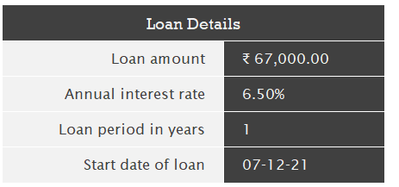

Details of payment are shown below:

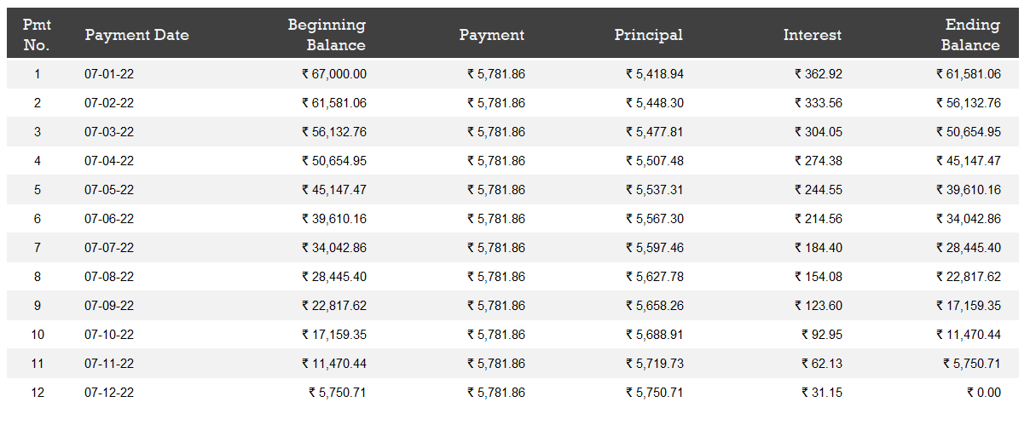

Loan summary:

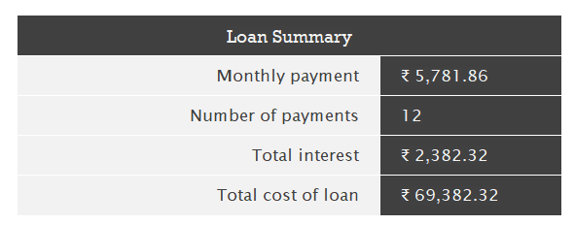

## B.2 Long term for 10-15 years

For long term loan we are considering long term loan to purchase my house.

To buy a house we are taking loan of 28.4 lakhs with interest rate of 8.3%.

The loan details are given below:

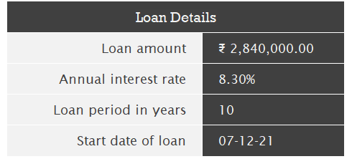

Payment details are shown below:

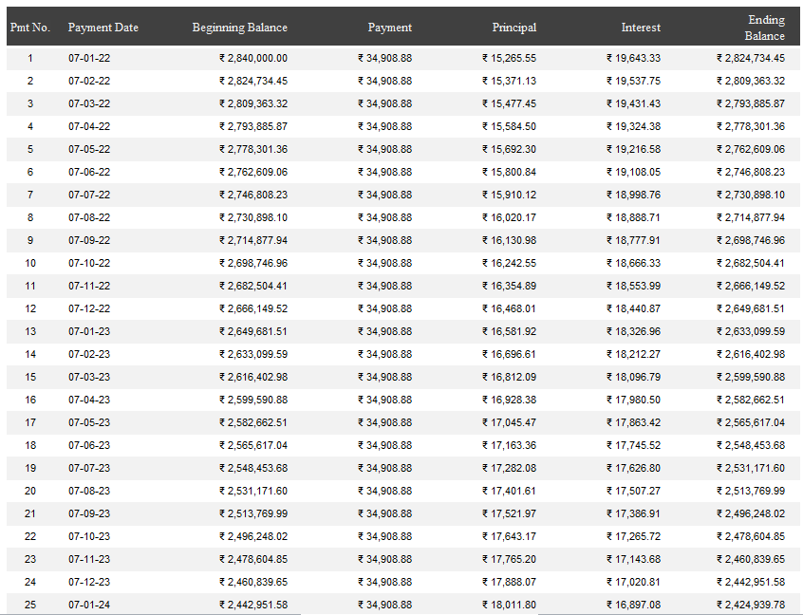

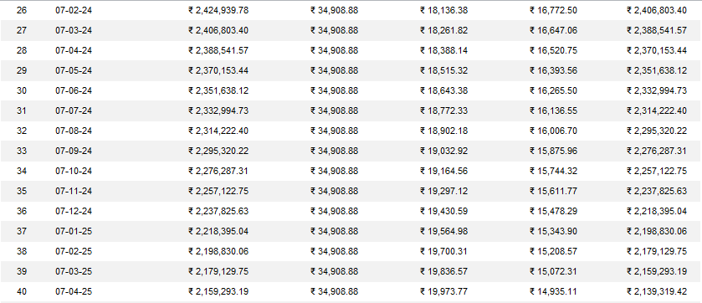

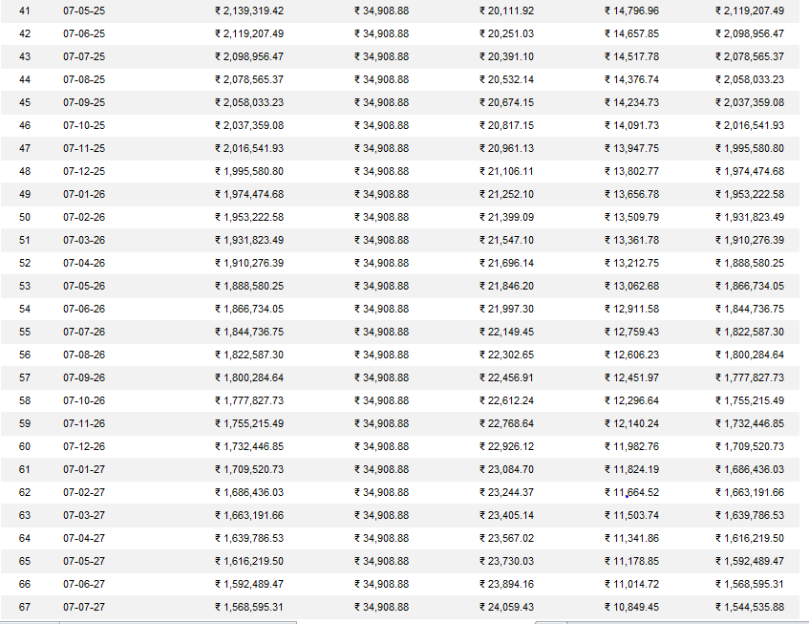

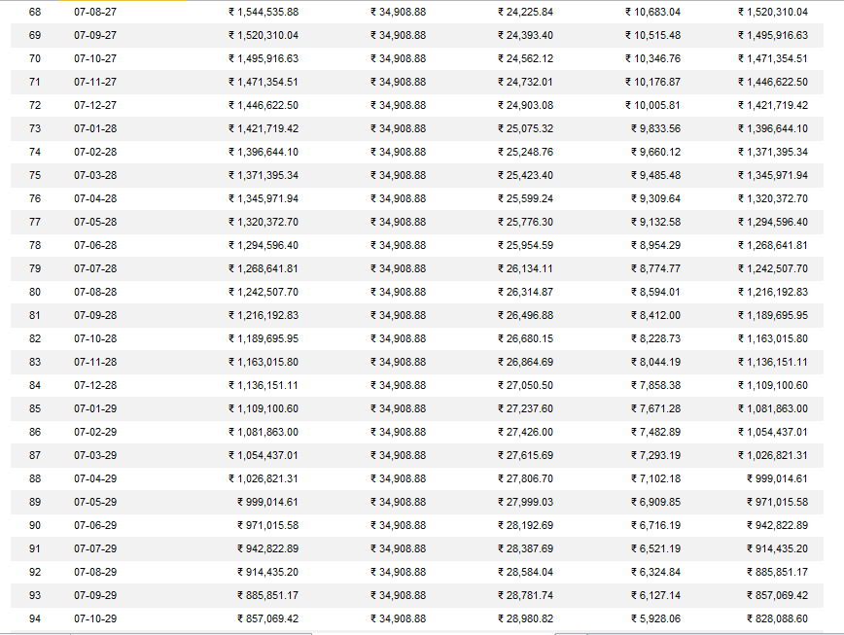

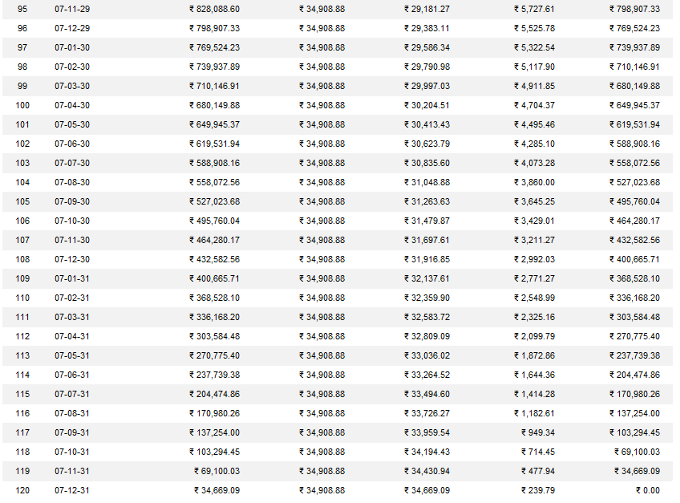

Loan summary:

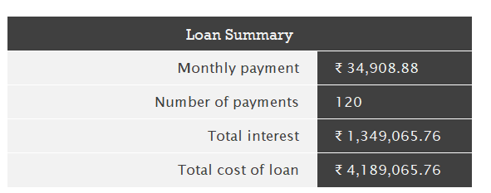

## B.3 Conclusion of the study with stance and justification

Short-term and long-term loans may refer to the time period in which a loan is paid back. Short term loans are generally to be repaid within a few months or a year or so. Long-term loan repayments can last for a few years up to several years (such as 10-15) years.

Short-term loans are generally associated with a need for quick money in small amounts. Examples of these are cash advance loans and loans derived from peer-to-peer lending. Long-term loans are generally required for larger amounts or for dealing with bigger transactions such as a home purchase loan.

Some loans can either be short term loans or long terms loans, or somewhere in-between. An example of this is with car loans, which can either be for larger amounts or smaller amounts depending on the arrangement.

In the above examples,

For short term loan of 1 year we need to pay total interest of 2382 rupees .

While in our long term loan for 10 years we need to pay 13.49 lakh rupees.

In short term loan our initial loan amount was 67000 rupees but in our long term loan our initial loan amount was 28.4 lakhs.

# **Question No. 3**

Prepare Personal Budget for the period of five years from 2022-2027 with the details assuming an income increment of 5-10% for each year which should include

**Solution to Question No. 3:**

## C.1 Select two stocks of your choice listed in National stock exchange from different sector and collect previous five-year monthly data of share prices of selected stock and corresponding index data.

## C.2 Determine Systematic and Unsystematic risks of each stock

## C.3 Determine the Expected return of the stocks using CAPM Model assuming risk free return as 6%.

## C.4 Conclusion of the study with stance and justification

**Bibliography**

________________________________________________________________________________